**Basketball Match Outcome Prediction Using Random Forest**

This document describes a pipeline for predicting basketball game outcomes using a Random Forest Classifier. The pipeline includes data loading, preprocessing, feature engineering, model training, evaluation, and saving the trained model.

**1. Overview**

The objective of this pipeline is to predict whether a basketball team wins a game based on historical match data. The process involves:

Data Loading and Preprocessing: Reading in the dataset, encoding categorical variables, dropping irrelevant columns, and filling missing values.

Feature Engineering: Creating new performance metrics (e.g., shooting percentages, assist-to-turnover ratio, rebound rates) and computing the margin of victory.

Model Training and Evaluation: Splitting the data into training and testing sets, training a Random Forest classifier, evaluating its performance using accuracy and AUC-ROC metrics, and saving the final model.

**2. Data Loading and Preprocessing**

**2.1 Data Import**

Dataset: The CSV file (basketball_matches_with_opponents.csv) is loaded using pandas.

Handling Missing Data: Missing values are filled using the median of each column to ensure that the dataset is complete.

**2.2 Encoding and Dropping Columns**

Label Encoding:

Team names for both the team and its opponent are encoded into numerical values using LabelEncoder.

Dropping Irrelevant Columns:

Columns such as game_id, team, opponent_team, and notD1_incomplete are dropped since they are not needed for model training.

**3. Feature Engineering**

Key basketball performance metrics are calculated to enrich the dataset:

FG2_PCT: Ratio of 2-point field goals made to attempted.

FG3_PCT: Ratio of 3-point field goals made to attempted.

FT_PCT: Free throw percentage (made/free throws attempted).

AST_TO_RATIO: Ratio of assists to turnovers.

DREB_RATE and OREB_RATE: Rates calculated from defensive and offensive rebounds.

TURNOVER_RATE: Turnovers relative to the sum of field goal attempts and free throw attempts.

MARGIN_VICTORY: Difference between the team's score and the opponent's score.

After computing these metrics, any NaN values resulting from division operations are replaced with zeros.

**4. Defining the Target Variable**

Win Indicator:

A new column Win is created where a value of 1 indicates a win (team score is greater than opponent score) and 0 indicates a loss.

**5. Data Splitting**

Training and Testing Sets:

The dataset is split into training and testing sets using an 80/20 split while ensuring that the target variable (Win) is stratified.

Feature Set:

The features used for model training exclude the target variable and columns directly related to game outcomes (e.g., scores and raw statistics).

**6. Model Training and Evaluation**

**6.1 Training the Model**

Random Forest Classifier:

A Random Forest model is initialized with 100 trees (n_estimators=100) and trained on the training data.

**6.2 Model Evaluation**

Predictions and Metrics:

The model predicts probabilities on the test set.

Accuracy: Computed by comparing binary predictions (using a threshold of 0.5) against actual outcomes.

AUC-ROC: Measures the model's ability to discriminate between the two classes (win vs. loss).

**7. Model Saving**

Persisting the Model:

The trained Random Forest model is saved to disk using joblib.dump, making it available for future predictions without retraining.

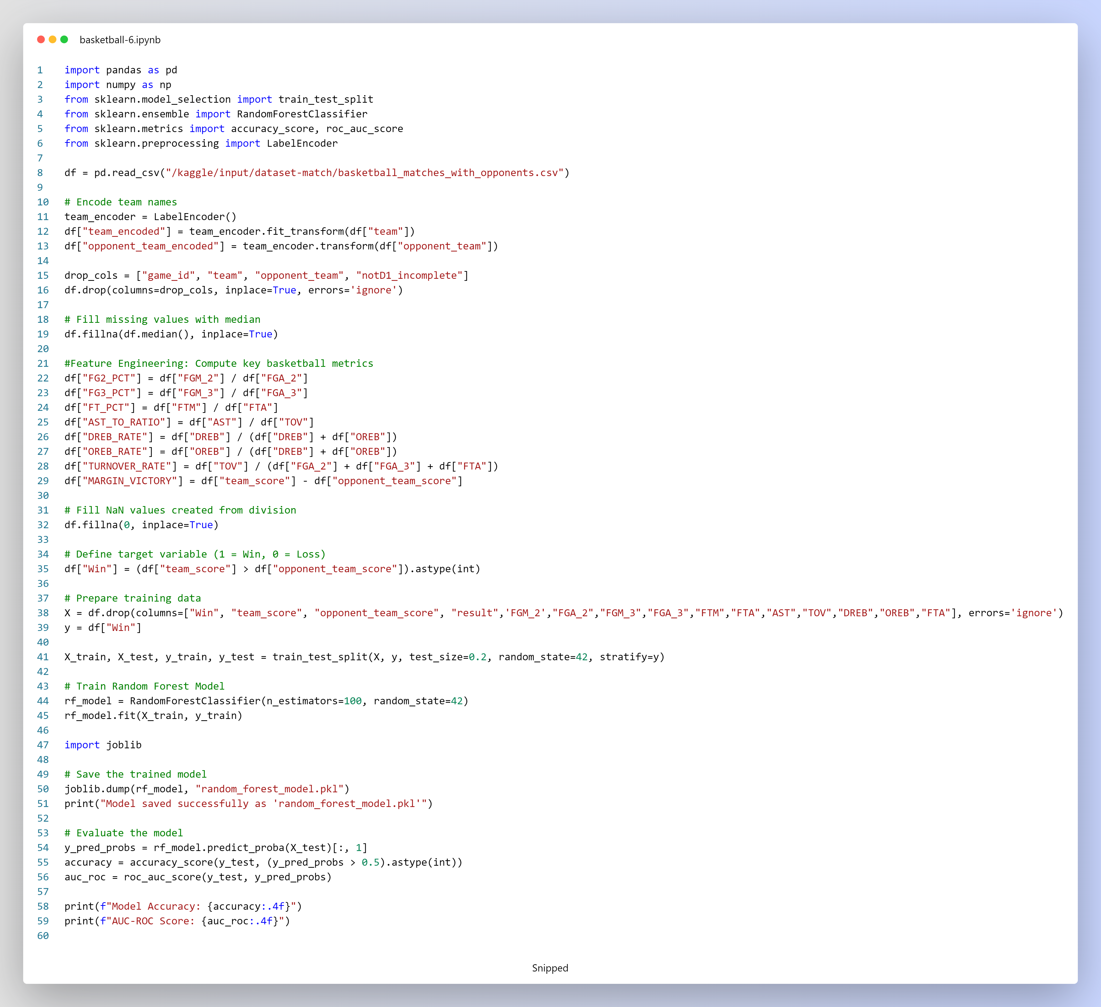

**8. Conclusion**

This pipeline demonstrates a complete workflow for predicting basketball game outcomes:

It starts with data preprocessing and feature engineering, where new performance metrics are derived.

A Random Forest Classifier is trained and evaluated, with performance measured via accuracy and AUC-ROC scores.

Finally, the model is saved for further analysis.

The methodology ensures that the prediction model captures key performance indicators that influence game outcomes, enabling robust classification of wins and losses.

**LSTM Sequence Data Preparation for Basketball Statistics Prediction**

This describes the process of preparing data for an LSTM model to predict key basketball statistics. The code performs feature normalization, sequence creation, and dataset splitting to generate input-output pairs suitable for time-series learning.

**1. Overview**

The goal of this pipeline is to transform basketball game statistics into sequences for training an LSTM network. The key steps are:

* **Feature Selection:** Identifying important basketball metrics.
* **Data Normalization:** Scaling features to ensure they are within a similar range.
* **Sequence Creation:** Converting the dataset into sequences of fixed length.
* **Dataset Splitting:** Dividing the data into training and testing sets.

**2. Detailed Steps**

**2.1 Importing Libraries**

* **NumPy and Pandas:** For numerical operations and data manipulation.
* **TensorFlow & Keras:** To build and later train the LSTM model.
* **Sklearn's MinMaxScaler:** For normalizing the feature values to a [0, 1] range.

**2.2 Feature Selection and Sequence Length**

* **Key Statistics (stat_features):**
  + FG2_PCT: 2-point field goal percentage.
  + FG3_PCT: 3-point field goal percentage.
  + FT_PCT: Free throw percentage.
  + AST_TO_RATIO: Assist-to-turnover ratio.
  + DREB_RATE: Defensive rebound rate.
  + OREB_RATE: Offensive rebound rate.
  + TURNOVER_RATE: Turnover rate.
  + MARGIN_VICTORY: Margin of victory.
* **Sequence Length:** Set to 5, which determines how many consecutive records form an input sequence.

**2.3 Data Normalization**

* **MinMaxScaler:**  
  The selected stat features are normalized using MinMaxScaler to scale each feature to a range between 0 and 1. This is important for neural network training as it improves convergence.

**2.4 Creating Sequences for LSTM**

* **Sequence Creation Function (create_sequences):**
  + **Input:** A dataframe for a given team, the selected stat features, and the desired sequence length.
  + **Process:**
    - Iterates through the dataframe to create sliding windows of consecutive records.
    - Each input sequence X contains sequence_length rows of the selected features.
    - The corresponding label y is the set of feature values immediately following the sequence.
  + **Output:** Two NumPy arrays: one for the sequences (X) and one for the labels (y).

**2.5 Splitting the Dataset**

* **Creating the LSTM Dataset:**  
  The create_sequences function is applied to the normalized dataframe to generate the full set of sequences (X_lstm) and labels (y_lstm).
* **Train-Test Split:**
  + The dataset is split into training and testing sets using an 80/20 ratio.
  + This division allows the LSTM model to be trained on the majority of the data while preserving a portion for evaluation.

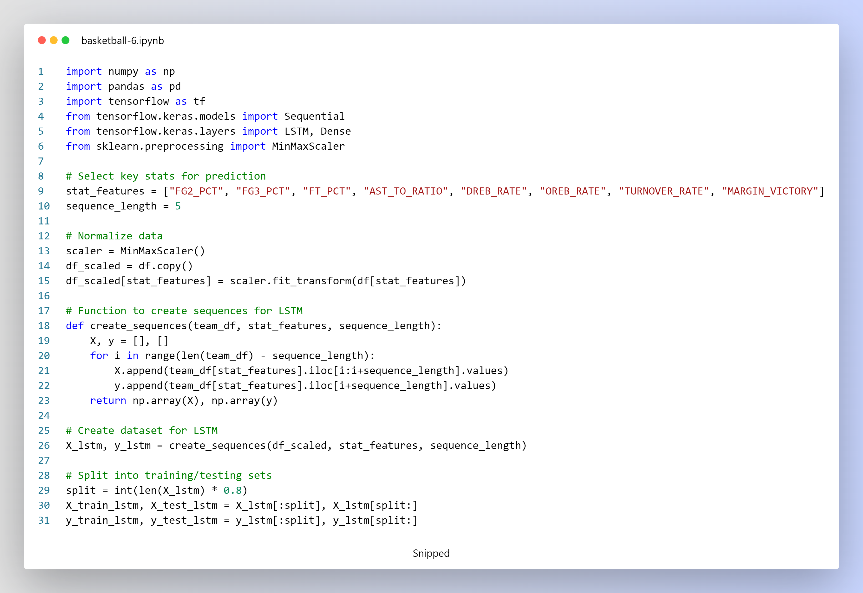

**3. Conclusion**

The code successfully transforms raw basketball statistics into a sequence-based format for LSTM training. By normalizing the data, creating sliding windows of features, and splitting the dataset, it sets up a robust foundation for time-series prediction of basketball game outcomes.

**LSTM Model for Basketball Statistic Prediction**

This section details the steps taken to build, train, evaluate, and save an LSTM model designed to predict basketball statistics. The model processes time-series data derived from key performance metrics and outputs predictions for these metrics.

**1. Model Architecture**

* **Input Layer:**
  + The model accepts sequences of length sequence_length (set to 5) with each time step containing a vector of values corresponding to the selected statistics (stat_features). The input shape is (sequence_length, len(stat_features)).
* **First LSTM Layer:**
  + **Units:** 64
  + **Activation:** ReLU
  + **Return Sequences:** Set to True to ensure that the entire sequence is passed on to the next LSTM layer.
* **Second LSTM Layer:**
  + **Units:** 32
  + **Activation:** ReLU
  + This layer processes the sequence output by the first LSTM and compresses the sequence information into a single output vector.
* **Dense Output Layer:**
  + **Units:** Equal to the number of features in stat_features
  + This layer produces the final predicted statistics for the next time step.

**2. Model Compilation**

* **Optimizer:** Adam
  + Chosen for its adaptive learning rate and effectiveness in training deep learning models.
* **Loss Function:** Mean Squared Error (MSE)
  + Used to measure the difference between the predicted and actual statistic values.

**3. Model Training**

* **Training Data:**
  + The input sequences (X_train_lstm) and their corresponding targets (y_train_lstm) are used for training.
* **Validation Data:**
  + Validation is performed using X_test_lstm and y_test_lstm to monitor the model’s performance on unseen data.
* **Training Parameters:**
  + **Epochs:** 50

**4. Model Evaluation**

* **Prediction:**
  + The trained model is used to predict the output on the test set (X_test_lstm), generating y_pred_lstm.
* **Evaluation Metrics:**
  + **Mean Squared Error (MSE):** Measures the average squared difference between predictions and actual values.
  + **Mean Absolute Error (MAE):** Measures the average absolute difference between predictions and actual values.

**5. Saving the Model**

* **Model Saving:**
  + After training and evaluation, the model is saved in the HDF5 format as lstm_stat_predictor.h5, allowing for future use without retraining.

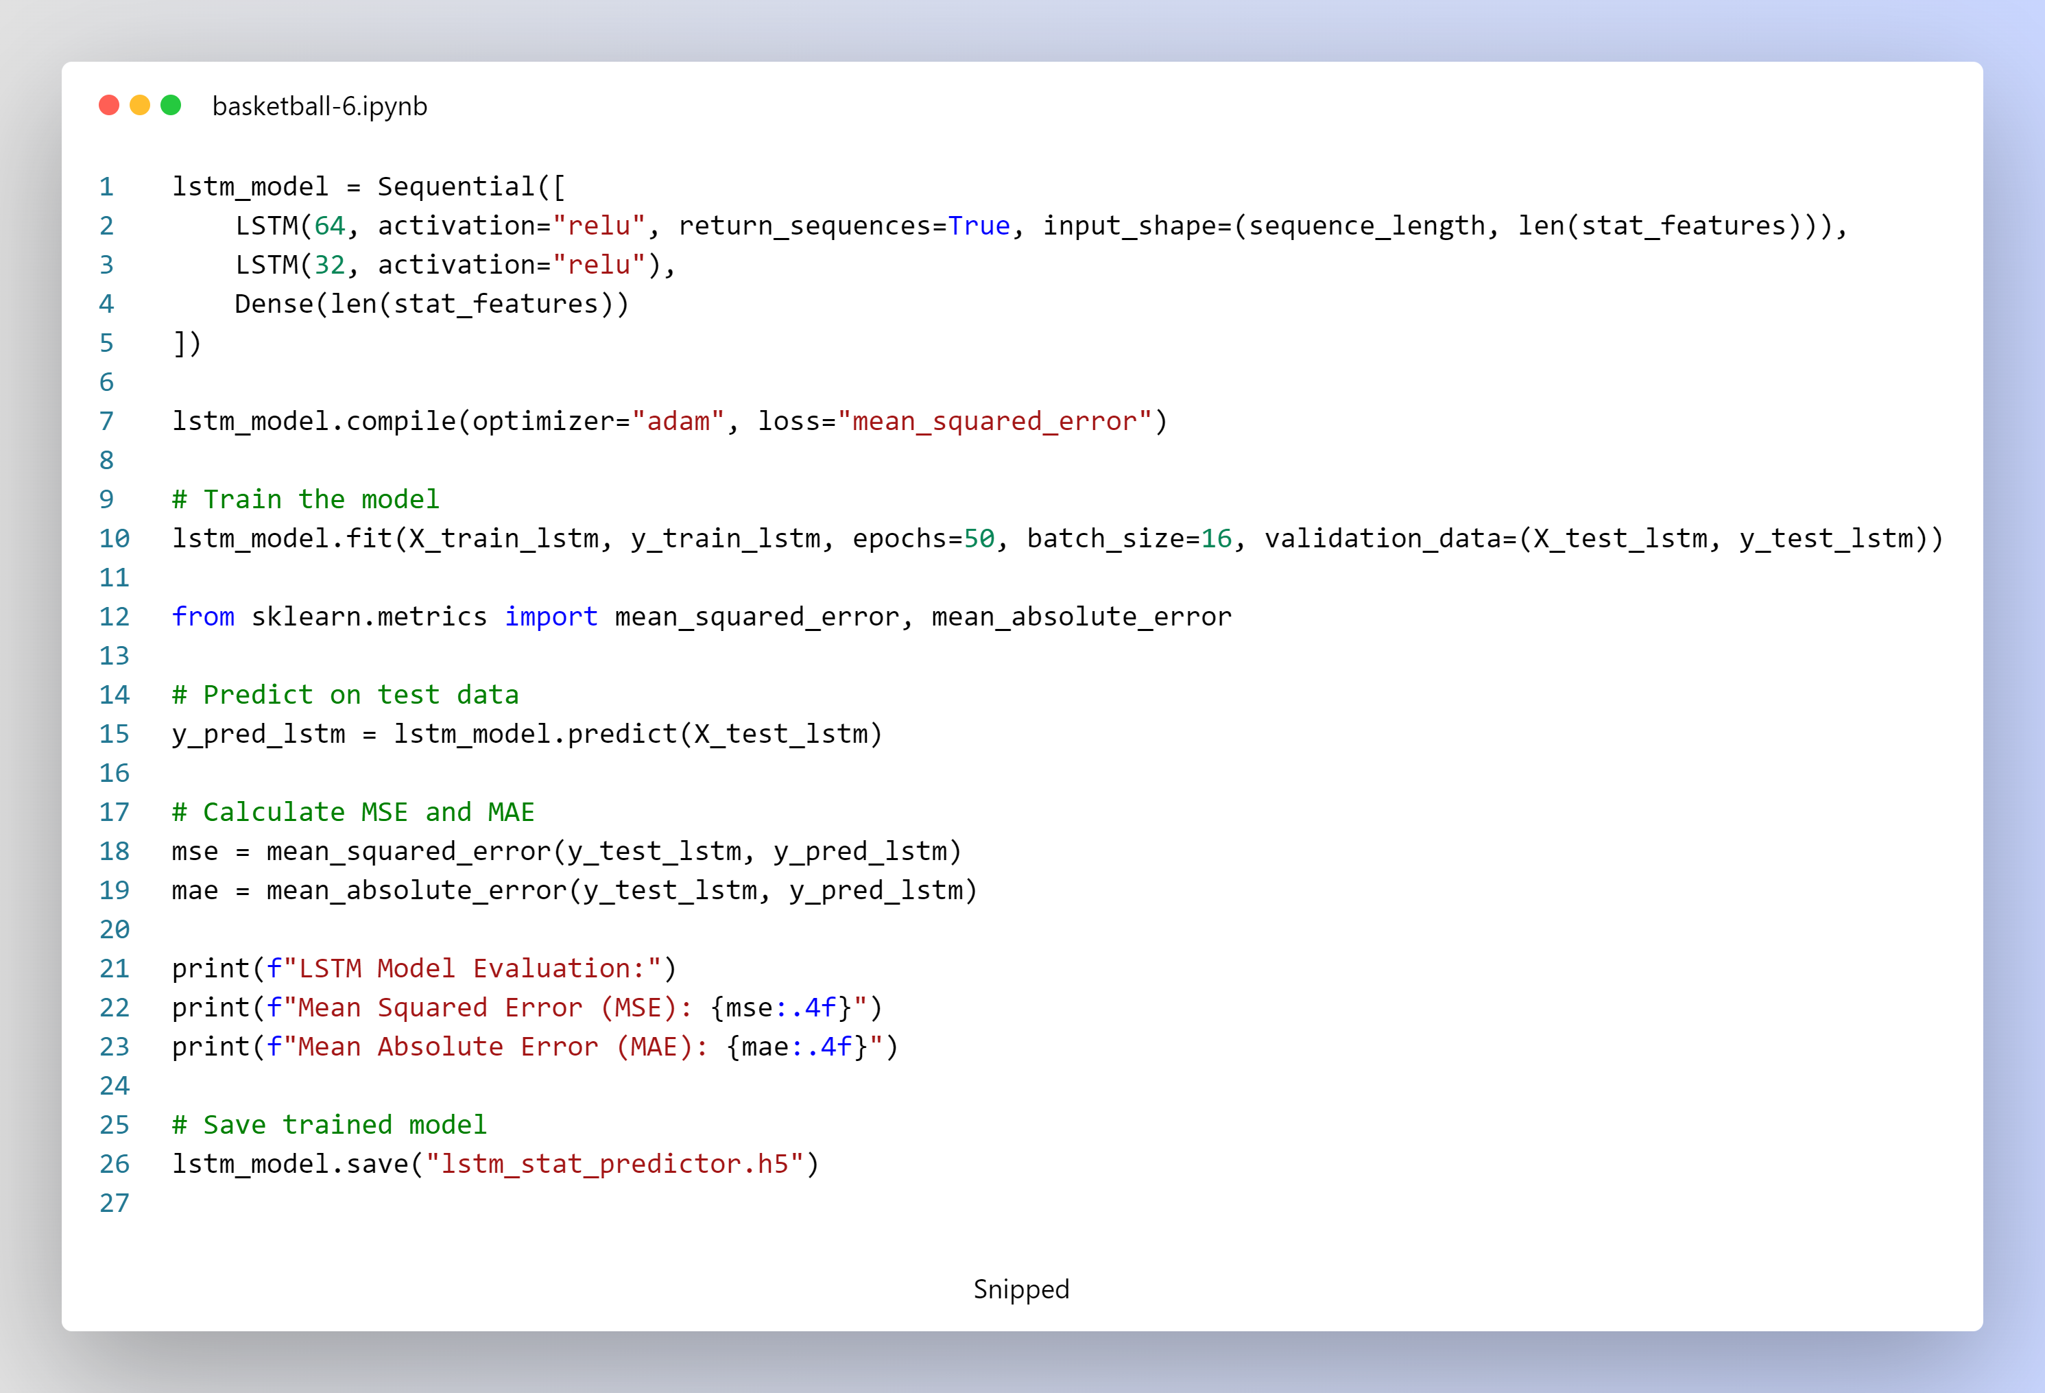

**Summary**

The LSTM model is built to forecast basketball statistics by learning temporal dependencies from normalized input sequences. By using a two-layer LSTM architecture and a Dense output layer, the model captures complex patterns in the time-series data. The training process uses the Adam optimizer and MSE loss, with performance evaluated through MSE and MAE. Finally, the trained model is saved for further analysis.

**Win Probability Prediction Based on Predicted Statistics**

This explains how the pipeline predicts a basketball team's win probability against an opponent using only the statistics predicted by a pre-trained LSTM model. The pipeline comprises two main functions:

1. **predict_future_stats(team_encoded)**:  
   Uses an LSTM model to forecast future key performance metrics for a given team based on its most recent historical data.
2. **predict_win_probability(team_name, opponent_name)**:  
   Utilizes the predicted statistics for both teams as input features to a pre-trained Random Forest model to estimate the win probability for a matchup.

**1. Loading the Pre-trained LSTM Model**

* **LSTM Model Loading:**  
  The LSTM model is loaded using TensorFlow's tf.keras.models.load_model from the file lstm_stat_predictor.h5.

**2. Predicting Future Statistics with LSTM**

**Function: predict_future_stats(team_encoded)**

* **Purpose:**  
  Predicts the next set of basketball statistics for a team based on its recent performance.
* **Process:**
  + **Team History Extraction:**  
    Retrieves the last sequence_length rows from the scaled dataframe df_scaled for the given team_encoded. If there isn’t enough data, it prints a message and returns None.
  + **Sequence Preparation:**  
    Formats the recent statistics into the required input shape for the LSTM model.
  + **Prediction:**  
    Uses the LSTM model to predict the next set of stats.
  + **Inverse Scaling:**  
    Converts the normalized predicted values back to their original scale using the scaler.inverse_transform.
  + **Output:**  
    Returns a dictionary mapping each stat (from stat_features) to its predicted value.

**3. Predicting Win Probability Using Predicted Stats**

**Function: predict_win_probability(team_name, opponent_name)**

* **Purpose:**  
  Computes the win probability for a given matchup by combining the predicted stats from the LSTM model with a Random Forest model trained on historical game data.
* **Process:**
  + **Team Validation and Encoding:**  
    Verifies that both team names exist in the dataset and transforms them into numerical labels using team_encoder.
  + **Predicting Future Stats:**  
    Retrieves the predicted future statistics for both the team and its opponent by calling predict_future_stats.
  + **Input Feature Preparation:**  
    Constructs a single-row dataframe with the following:
    - The predicted stats for the team (e.g., FG2_PCT, FG3_PCT, etc.).
    - The predicted stats for the opponent, stored under column names prefixed with "opponent_".
    - Encoded team identifiers.
    - The input is reordered to match the feature set (X.columns) that was used to train the Random Forest model.
  + **Win Probability Prediction:**  
    The Random Forest model (rf_model) computes the win probability based solely on the predicted stats.
  + **Result Display:**  
    Prints the matchup details, win probability, and the detailed predicted stats for both teams.
* **Example Call:**  
  The function is invoked for a matchup between "oklahoma_sooners" and "baylor_bears".

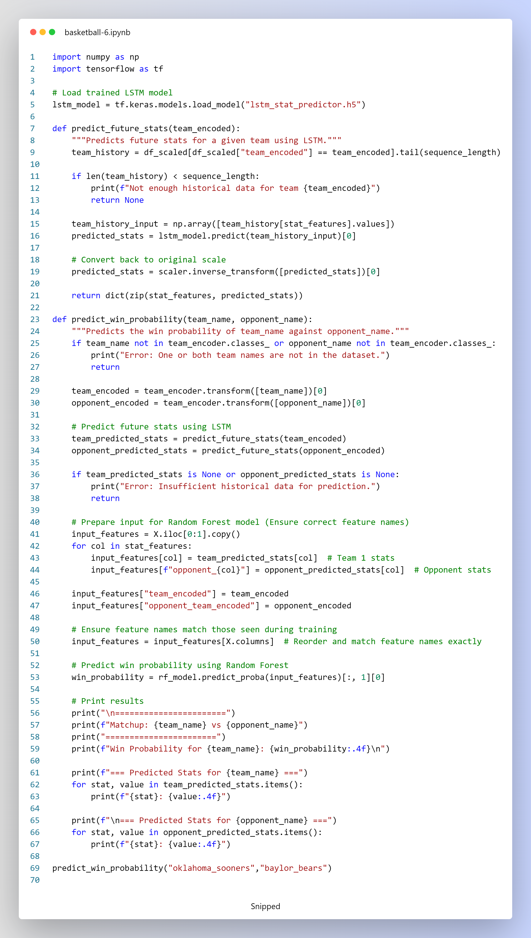

**4. Summary**

* **Predicted Statistics Only:**  
  The win probability is determined solely based on the statistics predicted by the LSTM model rather than historical data alone.
* **Hybrid Model Approach:**  
  By combining LSTM (for future stat prediction) and a Random Forest model (for win probability estimation), the pipeline provides a forward-looking assessment of game outcomes.
* **User Output:**  
  The predicted win probability and detailed predicted statistics for both teams are printed to the console, enabling a clear interpretation of the model's predictions.

**Win Probability Prediction Using Combined Mean and Predicted Stats**

This explains the pipeline for predicting a basketball team’s win probability against an opponent by combining historical (mean) statistics with future predictions generated by an LSTM model. A pre-trained Random Forest model then uses these combined features to compute the win probability.

**1. Overview**

The approach integrates two sources of information:

* **Historical Mean Statistics:**  
  The average performance metrics for each team based on past data.
* **LSTM Predicted Statistics:**  
  Future performance metrics forecasted by an LSTM model using recent data sequences.

These two sets of statistics are weighted (60% historical mean and 40% predicted) and combined into the input features for the Random Forest model. Finally, the model outputs the win probability for the matchup.

**2. Code Components**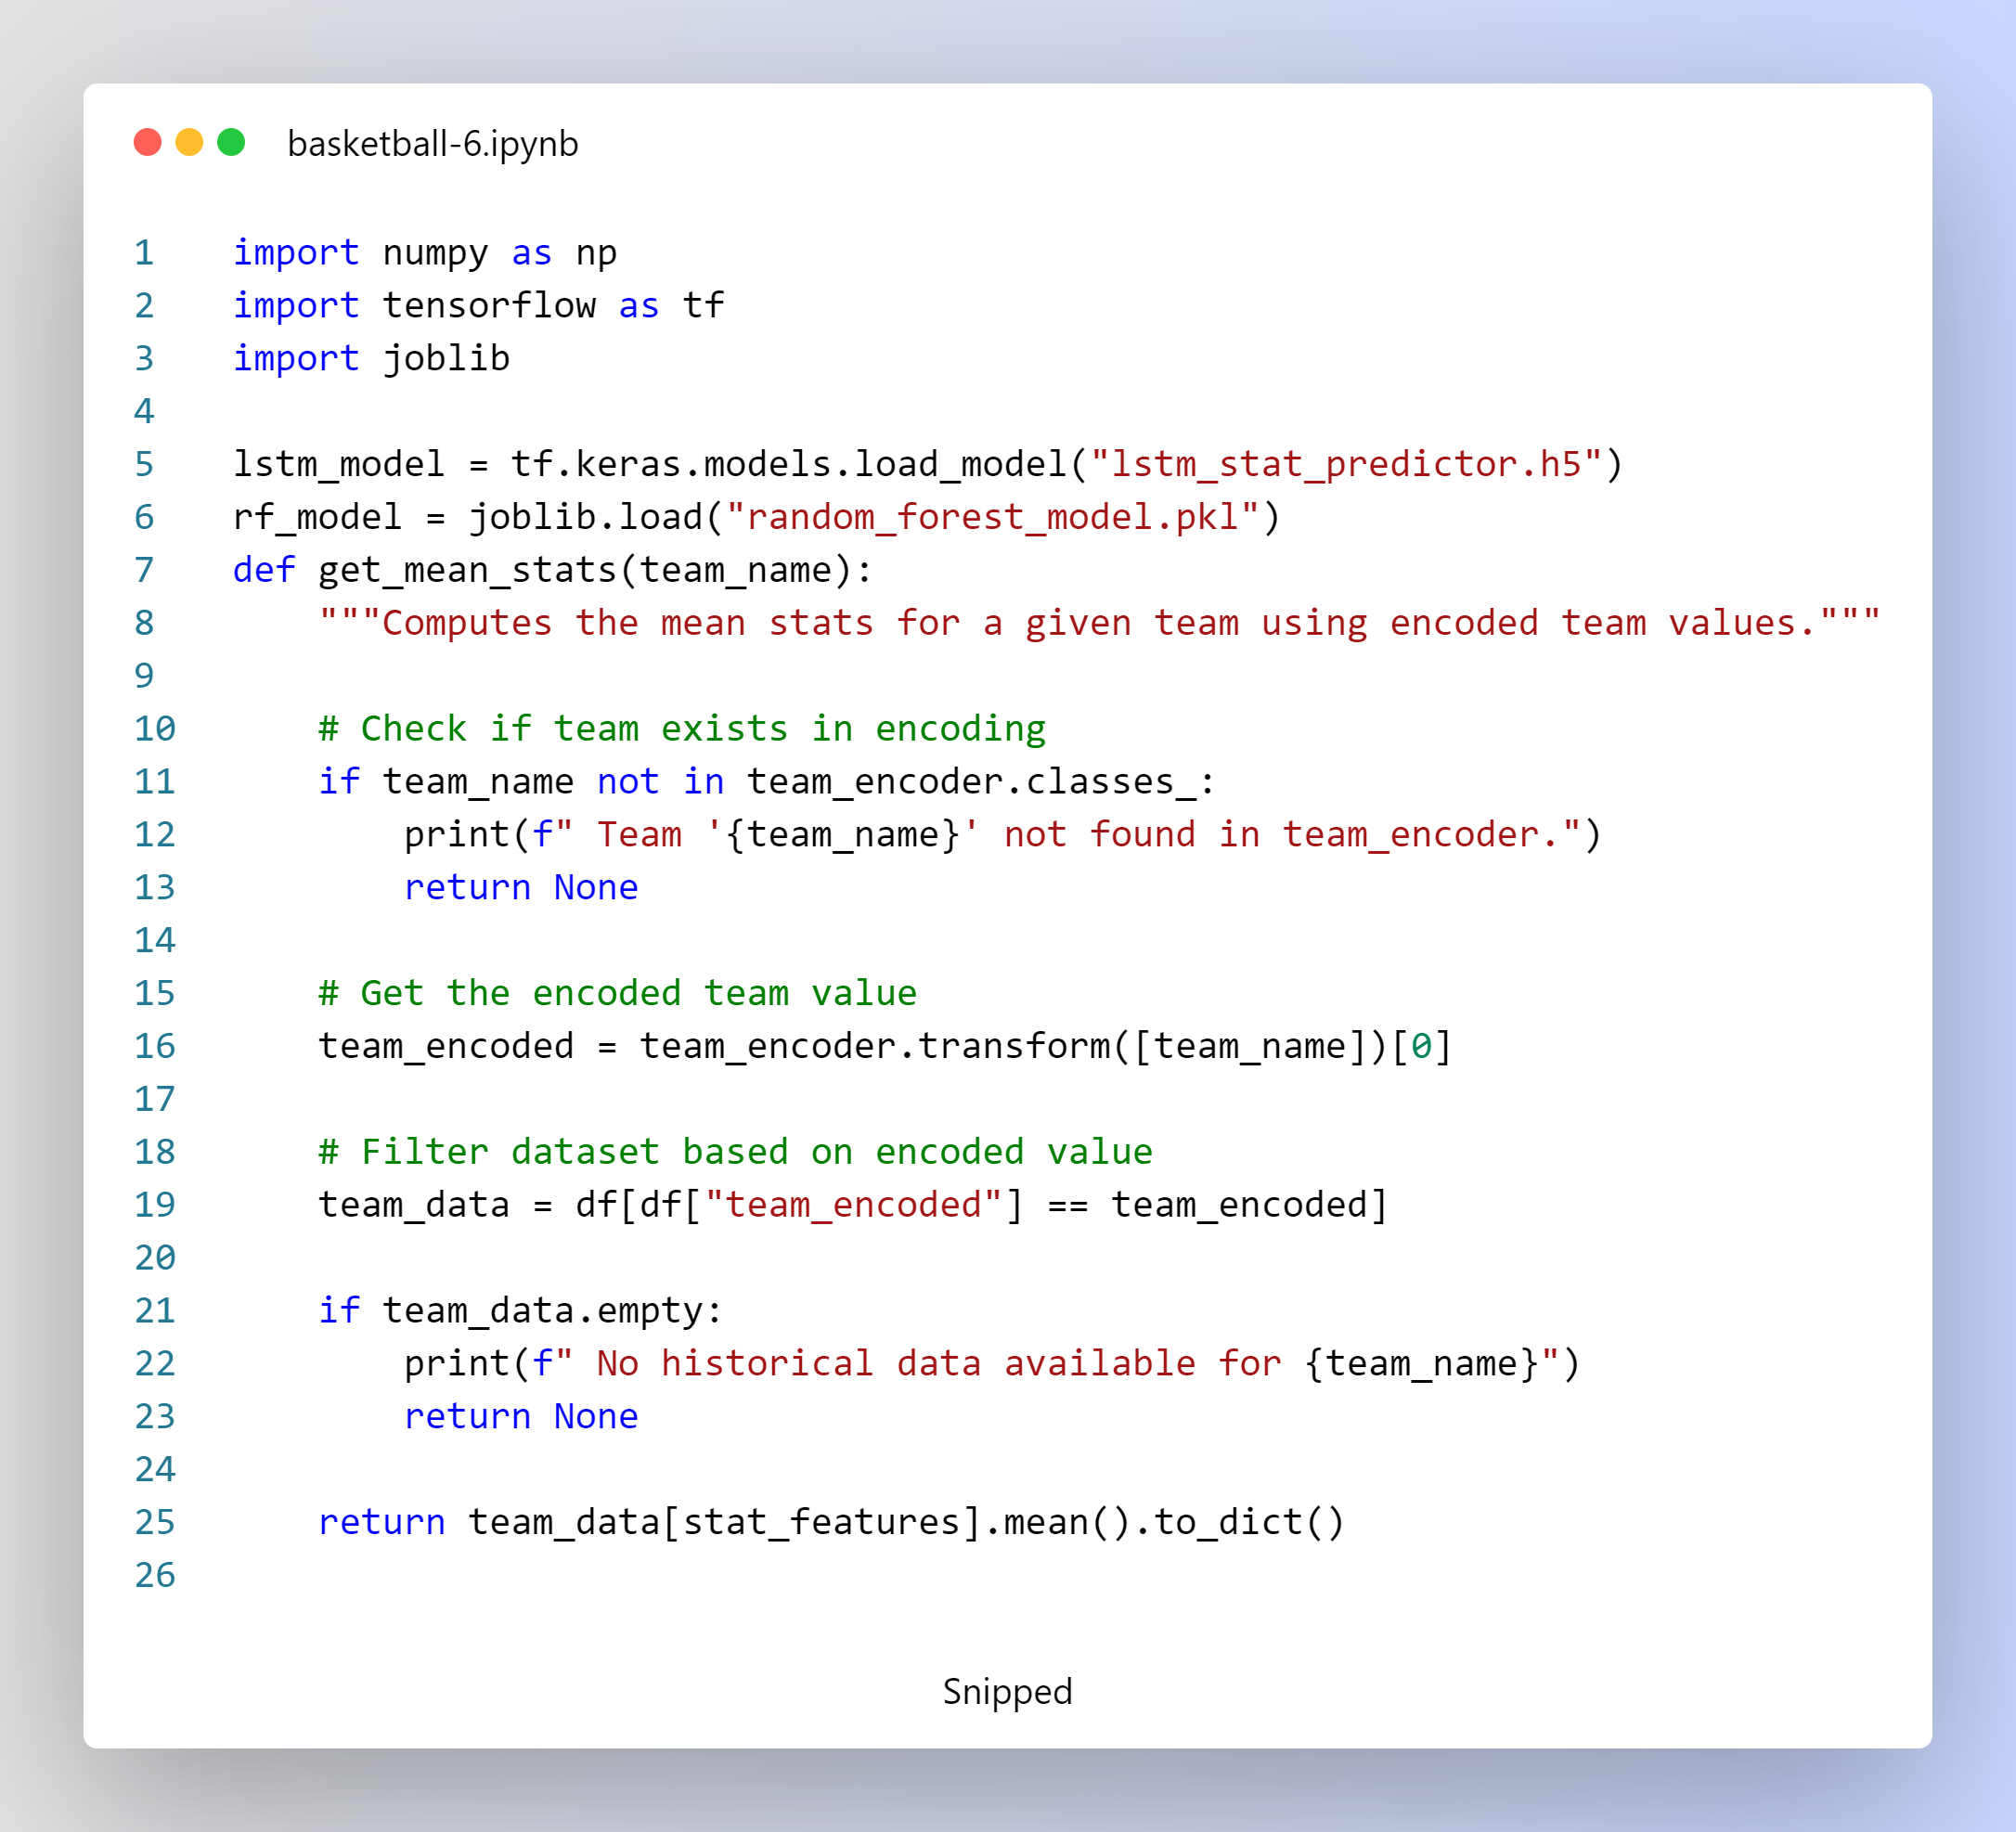

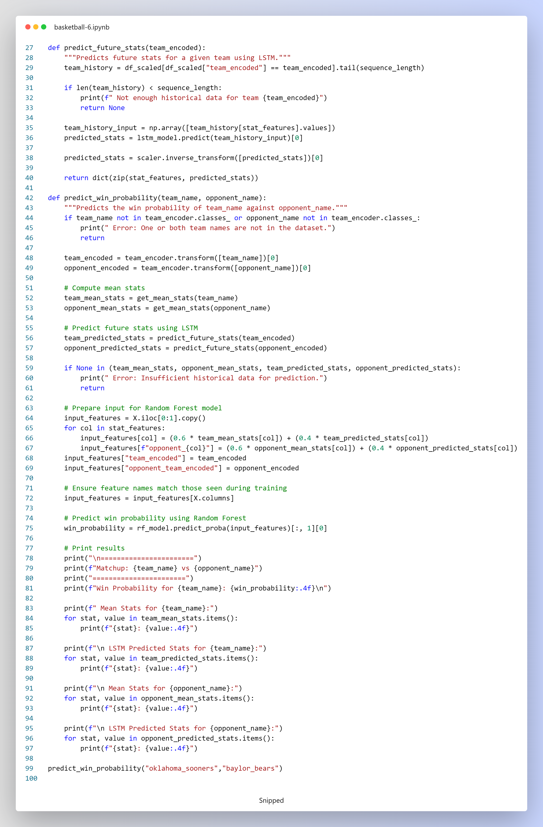

**2.1 Model Loading**

* **LSTM Model:**  
  Loaded from the file lstm_stat_predictor.h5 using TensorFlow.
* **Random Forest Model:**  
  Loaded from random_forest_model.pkl using Joblib.

**2.2 Mean Statistics Computation**

**Function: get_mean_stats(team_name)**

* **Purpose:**  
  Computes the mean values for the selected statistical features (stat_features) for a given team using the historical dataset (df).
* **Process:**
  + Verifies that the team name exists in the encoding.
  + Transforms the team name into its numerical encoding.
  + Filters the dataset for records corresponding to the encoded team.
  + Computes and returns the mean values for the specified statistics as a dictionary.

**2.3 Future Statistics Prediction Using LSTM**

**Function: predict_future_stats(team_encoded)**

* **Purpose:**  
  Predicts the future performance metrics for a team using the LSTM model.
* **Process:**
  + Retrieves the latest sequence_length records from the normalized dataset (df_scaled) for the given team.
  + Checks if there is sufficient historical data.
  + Formats these records as an input sequence for the LSTM model.
  + Uses the LSTM model to predict the next set of statistics.
  + Converts the normalized predicted values back to their original scale using the inverse transformation of the scaler.
  + Returns the predicted stats as a dictionary.

**2.4 Win Probability Prediction**

**Function: predict_win_probability(team_name, opponent_name)**

* **Purpose:**  
  Predicts the win probability for a matchup between team_name and opponent_name.
* **Process:**
  + Validates that both team names exist in the encoding.
  + Converts team names to their encoded values.
  + Retrieves historical mean stats for both teams using get_mean_stats.
  + Obtains future predictions for both teams using predict_future_stats.
  + Checks for sufficient data (both mean and predicted stats must be available).
  + **Combining Stats:**
    - For each statistical feature, a weighted average is computed:
      * **Weight:** 60% from historical mean stats and 40% from LSTM predicted stats.
    - This is done separately for the team and its opponent (with opponent features prefixed by "opponent_").
  + Constructs an input feature row ensuring it matches the feature order of the Random Forest training data.
  + Uses the Random Forest model to predict the win probability.
  + Prints the matchup, win probability, and a detailed breakdown of both the mean and predicted stats for each team.

**3. Execution Example**

The pipeline is executed by calling the predict_win_probability function with the desired team names. For example:

predict_win_probability("oklahoma_sooners","baylor_bears")

This call:

* Retrieves and combines the mean and predicted stats for both teams.
* Feeds the combined data into the Random Forest model.
* Outputs the win probability for "oklahoma_sooners" along with detailed breakdowns of both mean and LSTM predicted stats for both teams.

**4. Summary**

* **Hybrid Input Features:**  
  The model leverages both historical mean stats (60%) and LSTM-predicted stats (40%) to form robust input features.
* **Modular Functions:**  
  Separate functions handle mean stat calculation, LSTM-based future prediction, and win probability estimation.
* **Output:**  
  The final output displays the win probability and a comprehensive comparison of the historical and predicted stats for both competing teams.

This gives details to you about code and explains how it integrates both historical and predicted information to estimate win probabilities

**Margin of Victory Prediction Using Historical Mean Stats**

This script predicts the margin of victory for a basketball matchup by comparing the historical average ("mean") points scored by each team. The prediction is made solely on the basis of historical statistics and simple arithmetic calculations.

**1. Overview**

The goal of this code is to estimate which team is expected to win a matchup by:

* **Computing Mean Statistics:**  
  For each team, the script calculates the average of key performance metrics (e.g., points scored) from historical data.
* **Predicting the Margin of Victory:**  
  The margin is computed as the difference between the team's average points and its opponent's average points.
* **Determining the Winner:**  
  The team with the higher mean points is predicted as the winner.

**2. Code Components**

**2.1 Model and Data Loading**

* **LSTM Model Loading:**  
  The LSTM model is loaded from a file (lstm_stat_predictor.h5) using TensorFlow.  
  *(Note: Although loaded, the LSTM model is not used in the margin prediction calculation.)*

**2.2 Computing Mean Statistics**

**Function: get_mean_stats(team_name)**

* **Purpose:**  
  Calculates the average (mean) statistics for a given team using historical data.
* **Process:**
  + Checks if the provided team name exists in the encoding (team_encoder).
  + Transforms the team name into its corresponding encoded value.
  + Filters the dataset (df) to retrieve records for the given team.
  + Computes and returns the mean for the selected statistical features (stat_features) as a dictionary.

**2.3 Margin of Victory Prediction**

**Function: predict_margin_victory(team_name, opponent_name)**

* **Purpose:**  
  Uses the historical mean points for two teams to predict the margin of victory.
* **Process:**
  + Validates that both team names exist in the dataset.
  + Retrieves the mean statistics for both teams using get_mean_stats.
  + Calculates the margin of victory as the difference between the team's mean "points" and the opponent's mean "points".
  + Determines the predicted winner based on which team has the higher mean points.
  + Prints out the matchup, predicted margin, winner, and a detailed breakdown of mean statistics for both teams.

**3. Execution**

To run the margin prediction for a specific matchup, the function predict_margin_victory is called with the names of the two teams. For example:

predict_margin_victory("oklahoma_sooners", "baylor_bears")

This call will:

* Compute the mean statistics for "oklahoma_sooners" and "baylor_bears".
* Calculate the margin of victory based on the difference in average points.
* Print the predicted margin, the winner, and a detailed breakdown of each team's mean stats.

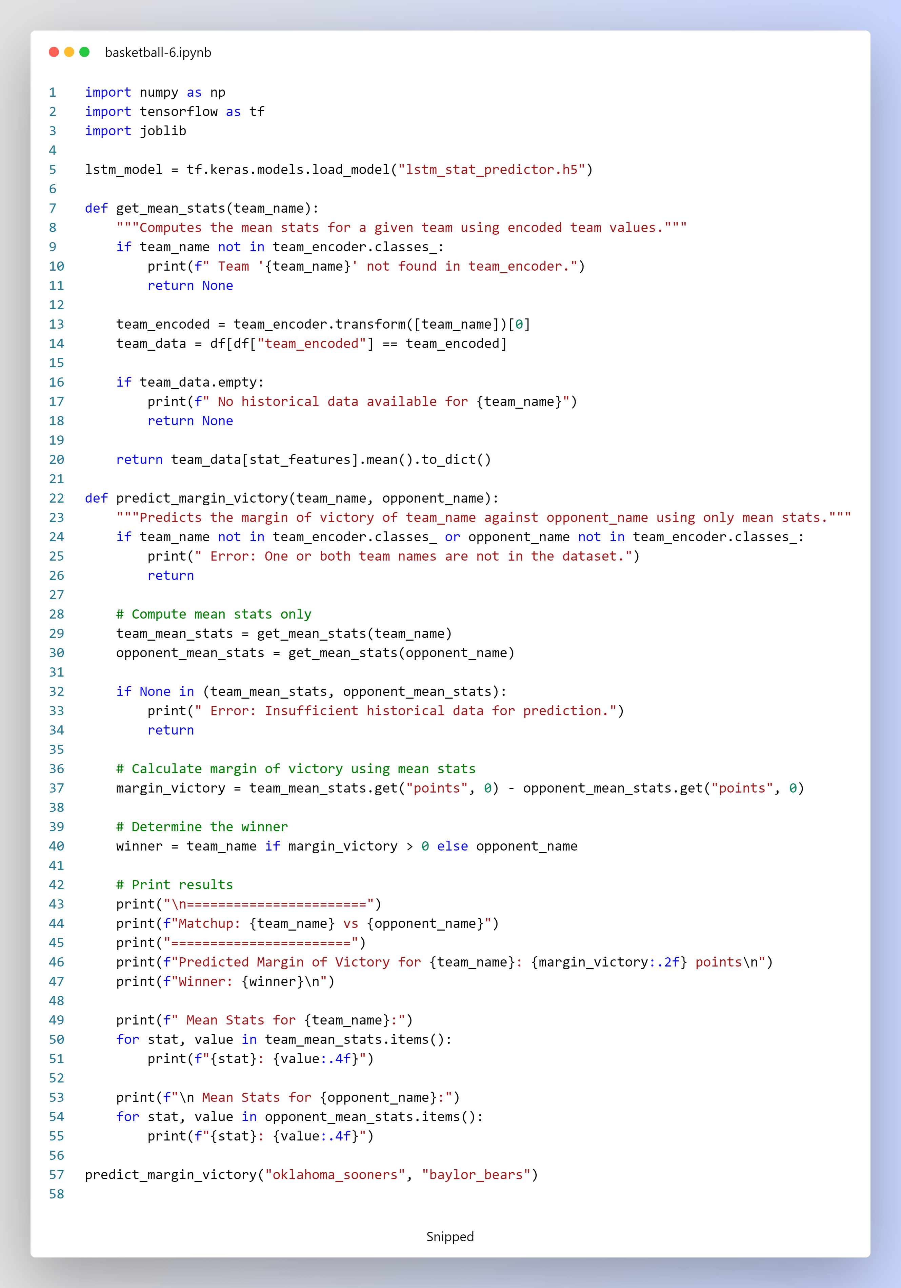

**4. Summary**

* **Input:**  
  Historical performance data for each team.
* **Calculation:**  
  The margin of victory is computed as the difference between the mean "points" of the two teams.
* **Output:**  
  The script prints the predicted margin of victory along with a detailed summary of the mean statistics for both teams and the predicted winner.

This explains how the code utilizes historical mean statistics to make predictions about game outcomes based solely on simple arithmetic calculations.

**Win Probability Prediction Using Head-to-Head Mean and Predicted Stats**

This code estimates the win probability of one basketball team over its opponent by leveraging:

* **Head-to-Head Mean Stats:**  
  Calculated solely from historical matchups between the two teams.
* **LSTM Predicted Stats:**  
  Forecasted future performance metrics for each team based on recent trends.

The two sources are combined with weights (80% mean, 20% prediction) and fed into a Random Forest model to produce the win probability.

**1. Model and Data Loading**

* **LSTM Model:**  
  Loaded using TensorFlow from lstm_stat_predictor.h5 to predict future performance stats.
* **Random Forest Model:**  
  Loaded using Joblib from random_forest_model.pkl to predict win probability based on input features.

**2. Function Definitions**

**2.1 Head-to-Head Mean Stats Calculation**

**get_matchup_mean_stats(team_name, opponent_name)**

* **Purpose:**  
  Computes the mean statistics for team_name from historical matches specifically against opponent_name.
* **Process:**
  + Validates that both team names are present in the team encoding.
  + Retrieves the encoded values for both teams.
  + Filters the dataset (df) to extract only those matches where team_name played against opponent_name.
  + Computes and returns the average (mean) of the selected statistical features (stat_features) as a dictionary.

**2.2 Future Statistics Prediction Using LSTM**

**predict_future_stats(team_encoded)**

* **Purpose:**  
  Predicts future statistics for a team using the LSTM model.
* **Process:**
  + Selects the latest sequence_length records from the normalized dataset (df_scaled) for the team.
  + If there are insufficient records, returns an error.
  + Prepares the data as a sequence input for the LSTM model.
  + Obtains the predicted stats and converts them back to their original scale using the scaler’s inverse transform.
  + Returns a dictionary mapping each stat from stat_features to its predicted value.

**2.3 Win Probability Prediction**

**predict_win_probability(team_name, opponent_name)**

* **Purpose:**  
  Predicts the win probability for team_name against opponent_name by combining head-to-head mean stats with LSTM predicted stats.
* **Process:**
  + Validates the existence of both team names in the dataset.
  + Retrieves the encoded values for each team.
  + Calls get_matchup_mean_stats to obtain historical mean stats for each team when playing against the other.
  + Calls predict_future_stats to get future predicted stats for both teams.
  + Checks that all necessary data is available.
  + For each statistic, computes a weighted average:
    - **Team's Feature:** 0.8 * mean + 0.2 * prediction
    - **Opponent's Feature:** Similar weighted combination (stored with the prefix opponent_).
  + Prepares an input feature row that matches the structure used during Random Forest training.
  + Uses the Random Forest model to compute the win probability.
  + Prints the matchup details, win probability, and a breakdown of both the head-to-head mean stats and LSTM predicted stats for each team.

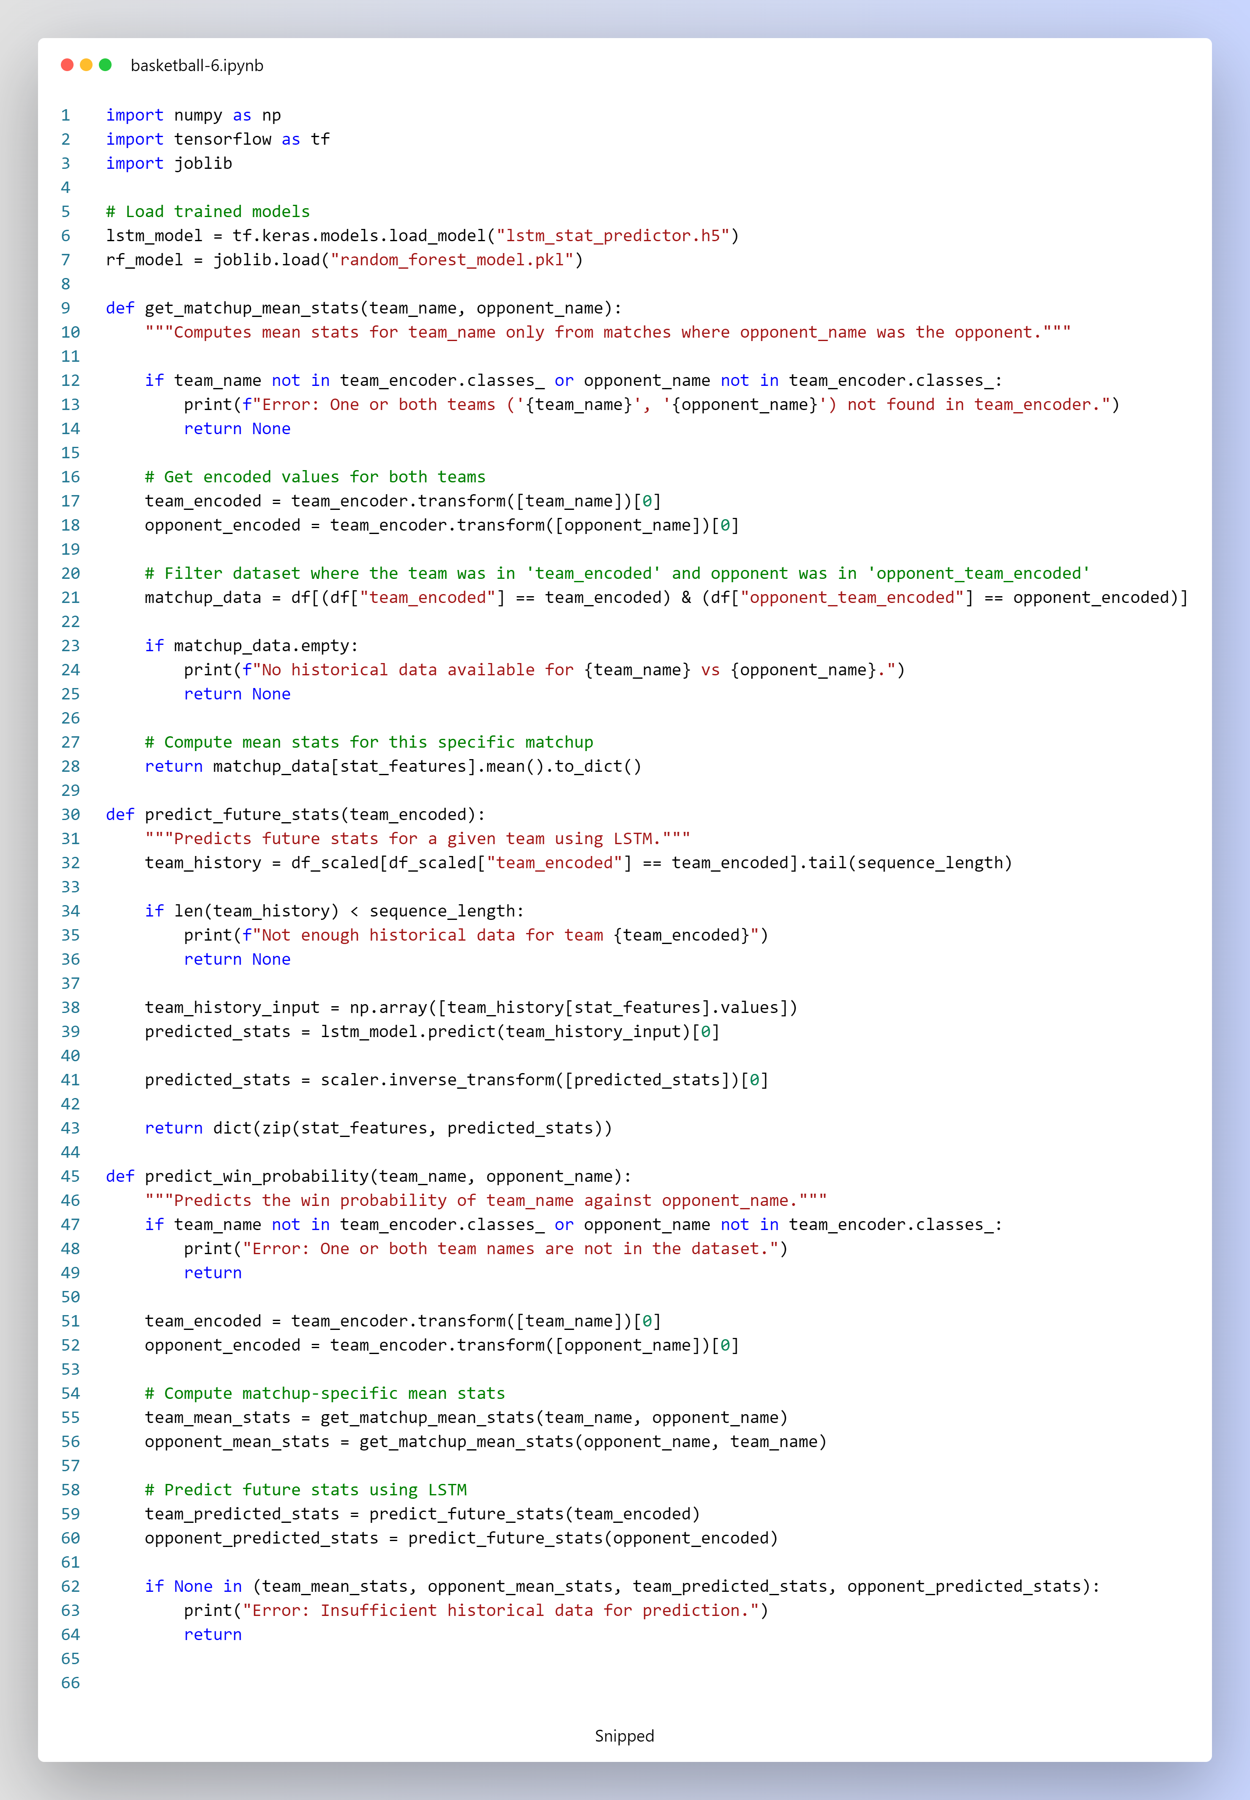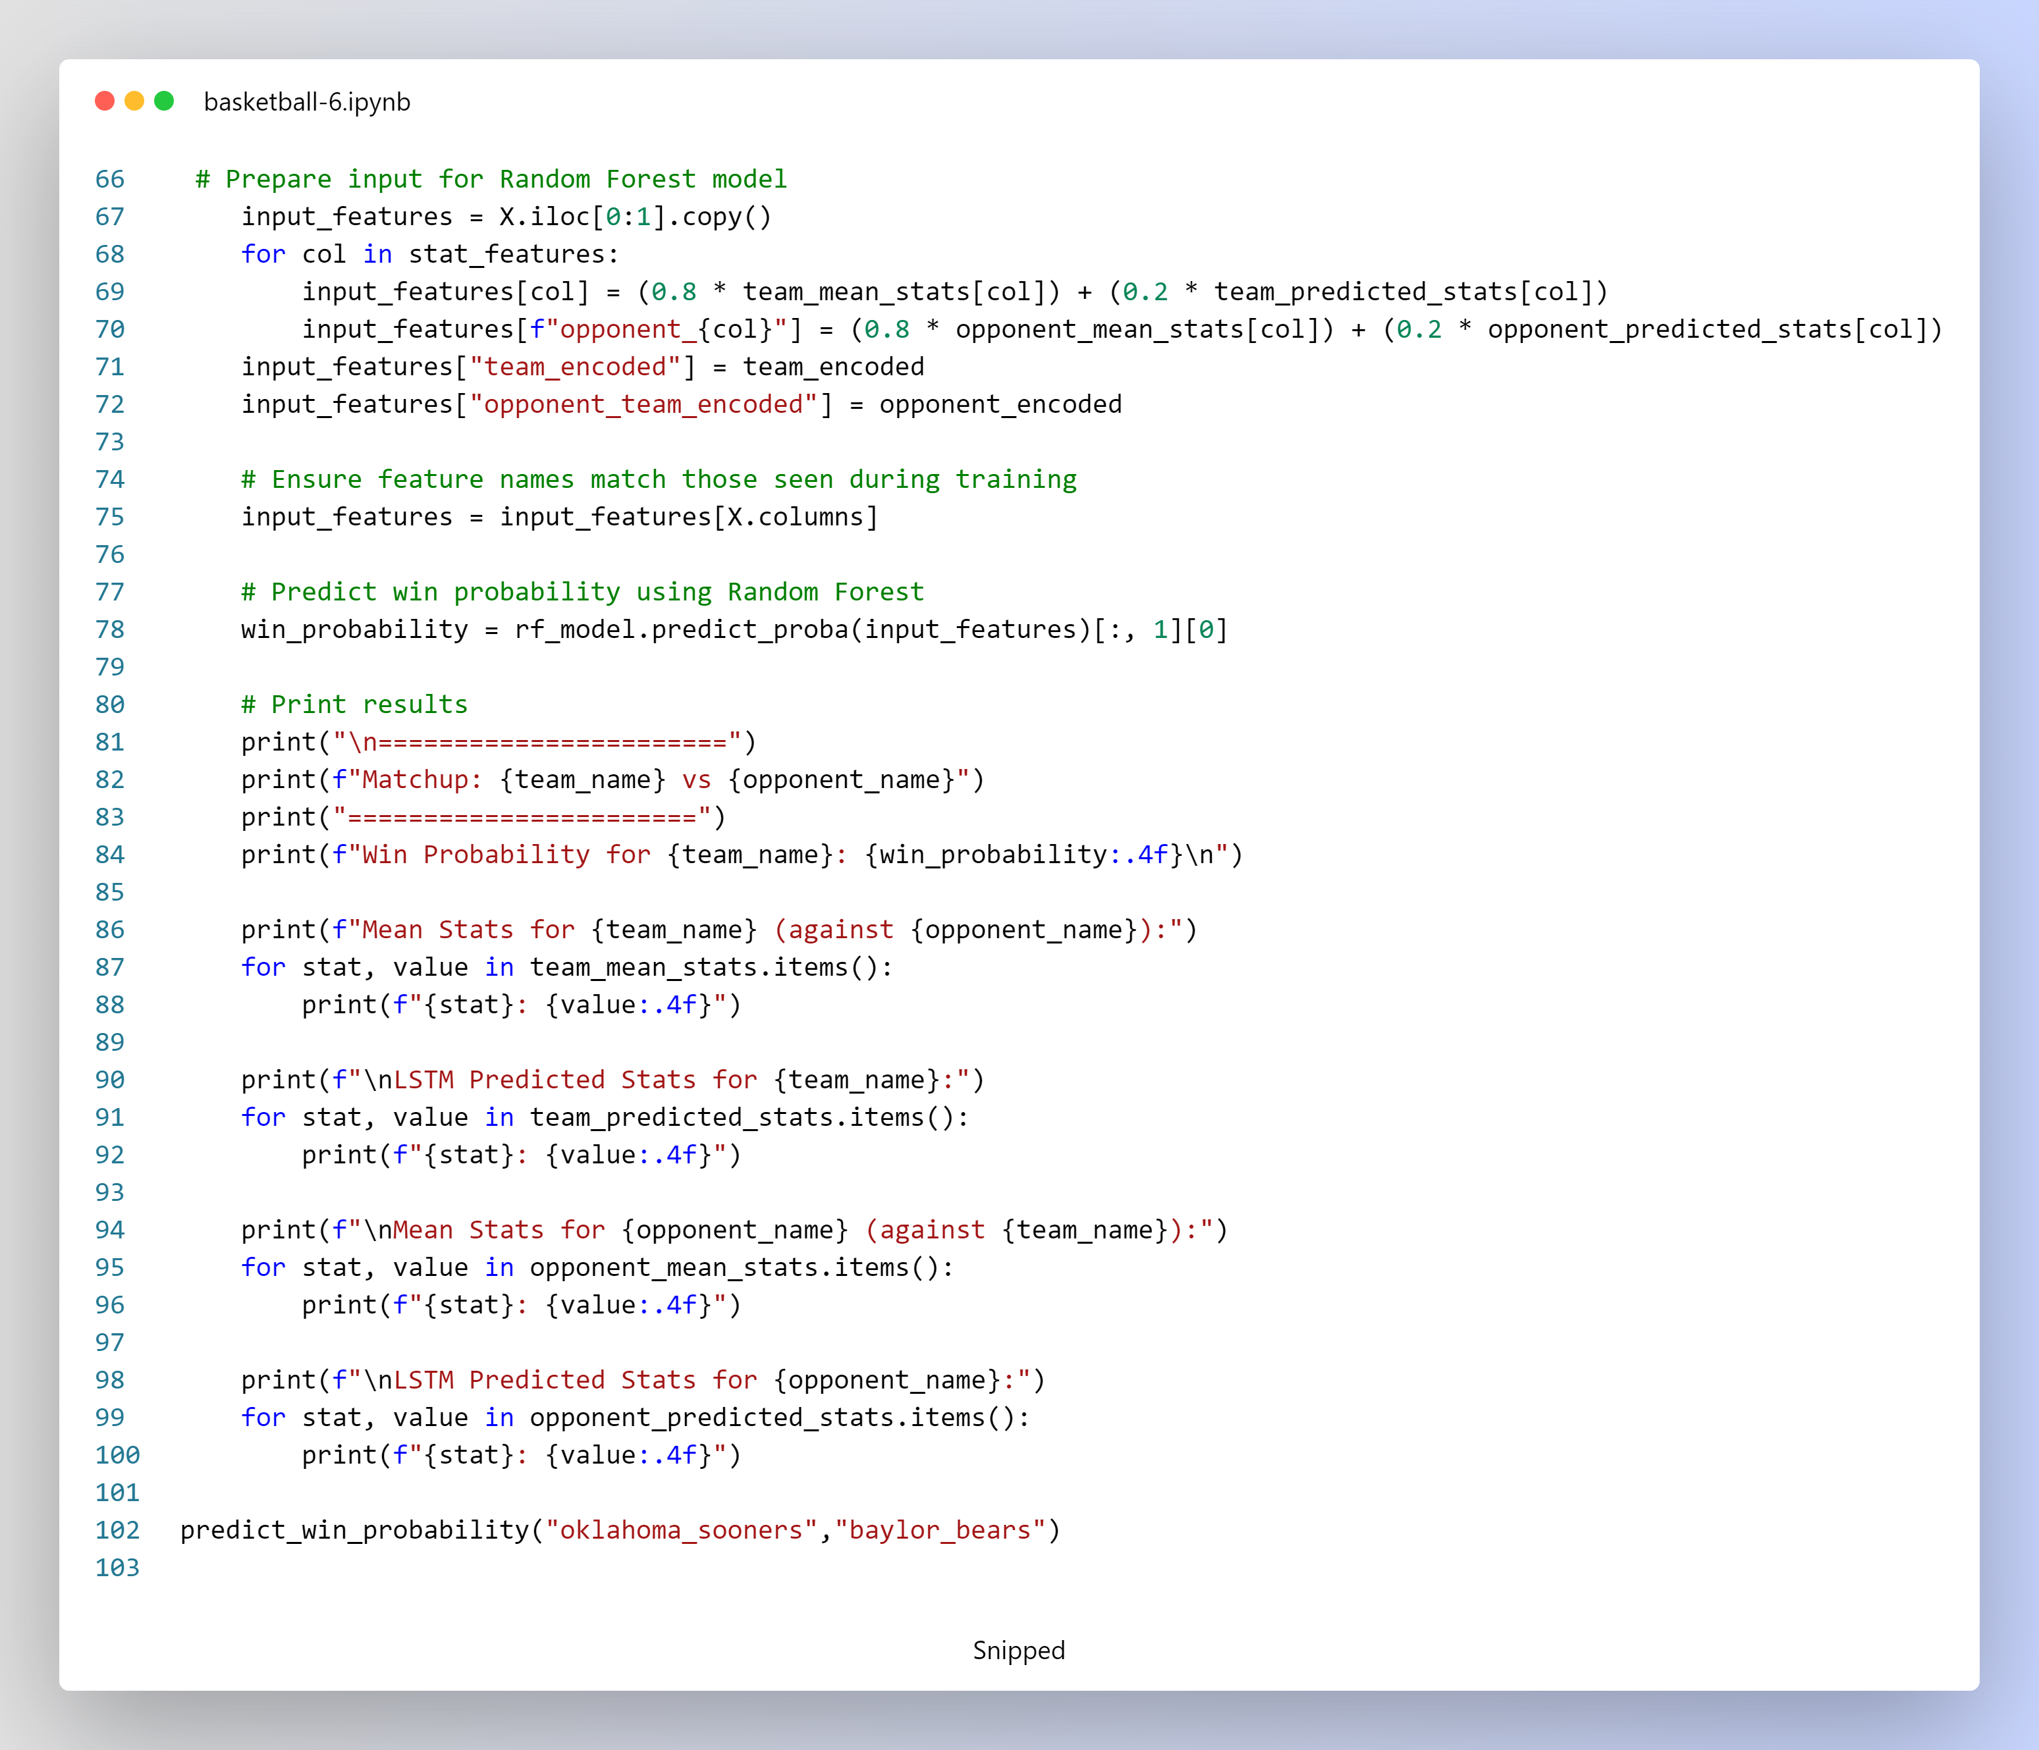

**3. Execution Example**

To predict the win probability for a matchup, simply call the predict_win_probability function with the names of the two teams. For example:

predict_win_probability("oklahoma_sooners", "baylor_bears")

This call will:

* Compute head-to-head mean statistics for "oklahoma_sooners" vs. "baylor_bears" and vice versa.
* Obtain LSTM predictions for future stats for both teams.
* Combine these statistics using the specified weights (80% mean, 20% predicted).
* Use the Random Forest model to compute and print the win probability, along with detailed stats for both teams.

**4. Summary**

* **Head-to-Head Mean Stats:**  
  Provide a historical baseline of team performance specifically against the given opponent.
* **LSTM Predicted Stats:**  
  Offer a forecast of future performance based on recent trends.
* **Weighted Combination:**  
  The final input features for the Random Forest model are calculated as an 80/20 blend of head-to-head means and LSTM predictions.
* **Win Probability:**  
  The Random Forest model outputs the probability that the specified team wins the matchup, with detailed outputs for transparency.

This explains how the code integrates historical matchup data with future predictions to produce a win probability estimate.

**Win Probability Prediction Using Head-to-Head Mean Stats**

This script estimates the win probability for a basketball matchup by comparing the historical average performance of two teams when they face each other. It uses only the head-to-head mean statistics (computed from past games) as input features for a pre-trained Random Forest model.

**1. Overview**

The approach consists of the following steps:

* **Head-to-Head Mean Stats Calculation:**  
  For a given matchup, the script filters historical data to extract games where the two teams played against each other and computes the mean of the selected statistical features.
* **Input Preparation for Prediction:**  
  The computed mean statistics for the team and its opponent are used to create an input feature vector that aligns with the Random Forest model’s training features.
* **Win Probability Prediction:**  
  The Random Forest model predicts the win probability for the team based solely on these head-to-head mean statistics.

**2. Code Components**

**2.1 Model and Data Loading**

* **LSTM Model:**  
  Although loaded, the LSTM model is not used in this prediction—it’s available from the same pipeline.

lstm_model = tf.keras.models.load_model("lstm_stat_predictor.h5")

* **Random Forest Model:**  
  Loaded using Joblib, this model is used to compute the win probability from the feature inputs.

**2.2 Head-to-Head Mean Statistics Calculation**

**Function: get_matchup_mean_stats(team_name, opponent_name)**

* **Purpose:**  
  Calculates the average (mean) performance statistics for team_name in games where it faced opponent_name.
* **Process:**
  + Verifies that both team names exist in the dataset using the team encoder.
  + Transforms team names into encoded values.
  + Filters the dataset (df) for matches where team_encoded equals the team's encoded value and opponent_team_encoded equals the opponent's encoded value.
  + Computes and returns the mean values for the selected statistical features (stat_features).

**2.3 Win Probability Prediction**

**Function: predict_win_probability(team_name, opponent_name)**

* **Purpose:**  
  Uses only the head-to-head mean statistics from historical matchups to predict the win probability of team_name against opponent_name.
* **Process:**
  + Checks that both team names are present in the team encoder.
  + Retrieves the encoded values for both teams.
  + Computes the matchup-specific mean statistics for both the team and the opponent by calling get_matchup_mean_stats.
  + Prepares an input feature row by:
    - Assigning each feature for the team the corresponding value from its head-to-head mean stats.
    - Assigning the opponent's features (prefixed with "opponent_") similarly from its head-to-head mean stats.
    - Including the encoded team identifiers.
  + Reorders the input features to match the structure used during Random Forest model training.
  + Uses the Random Forest model to compute the win probability.
  + Prints the matchup details, win probability, and a breakdown of the head-to-head mean statistics for both teams.

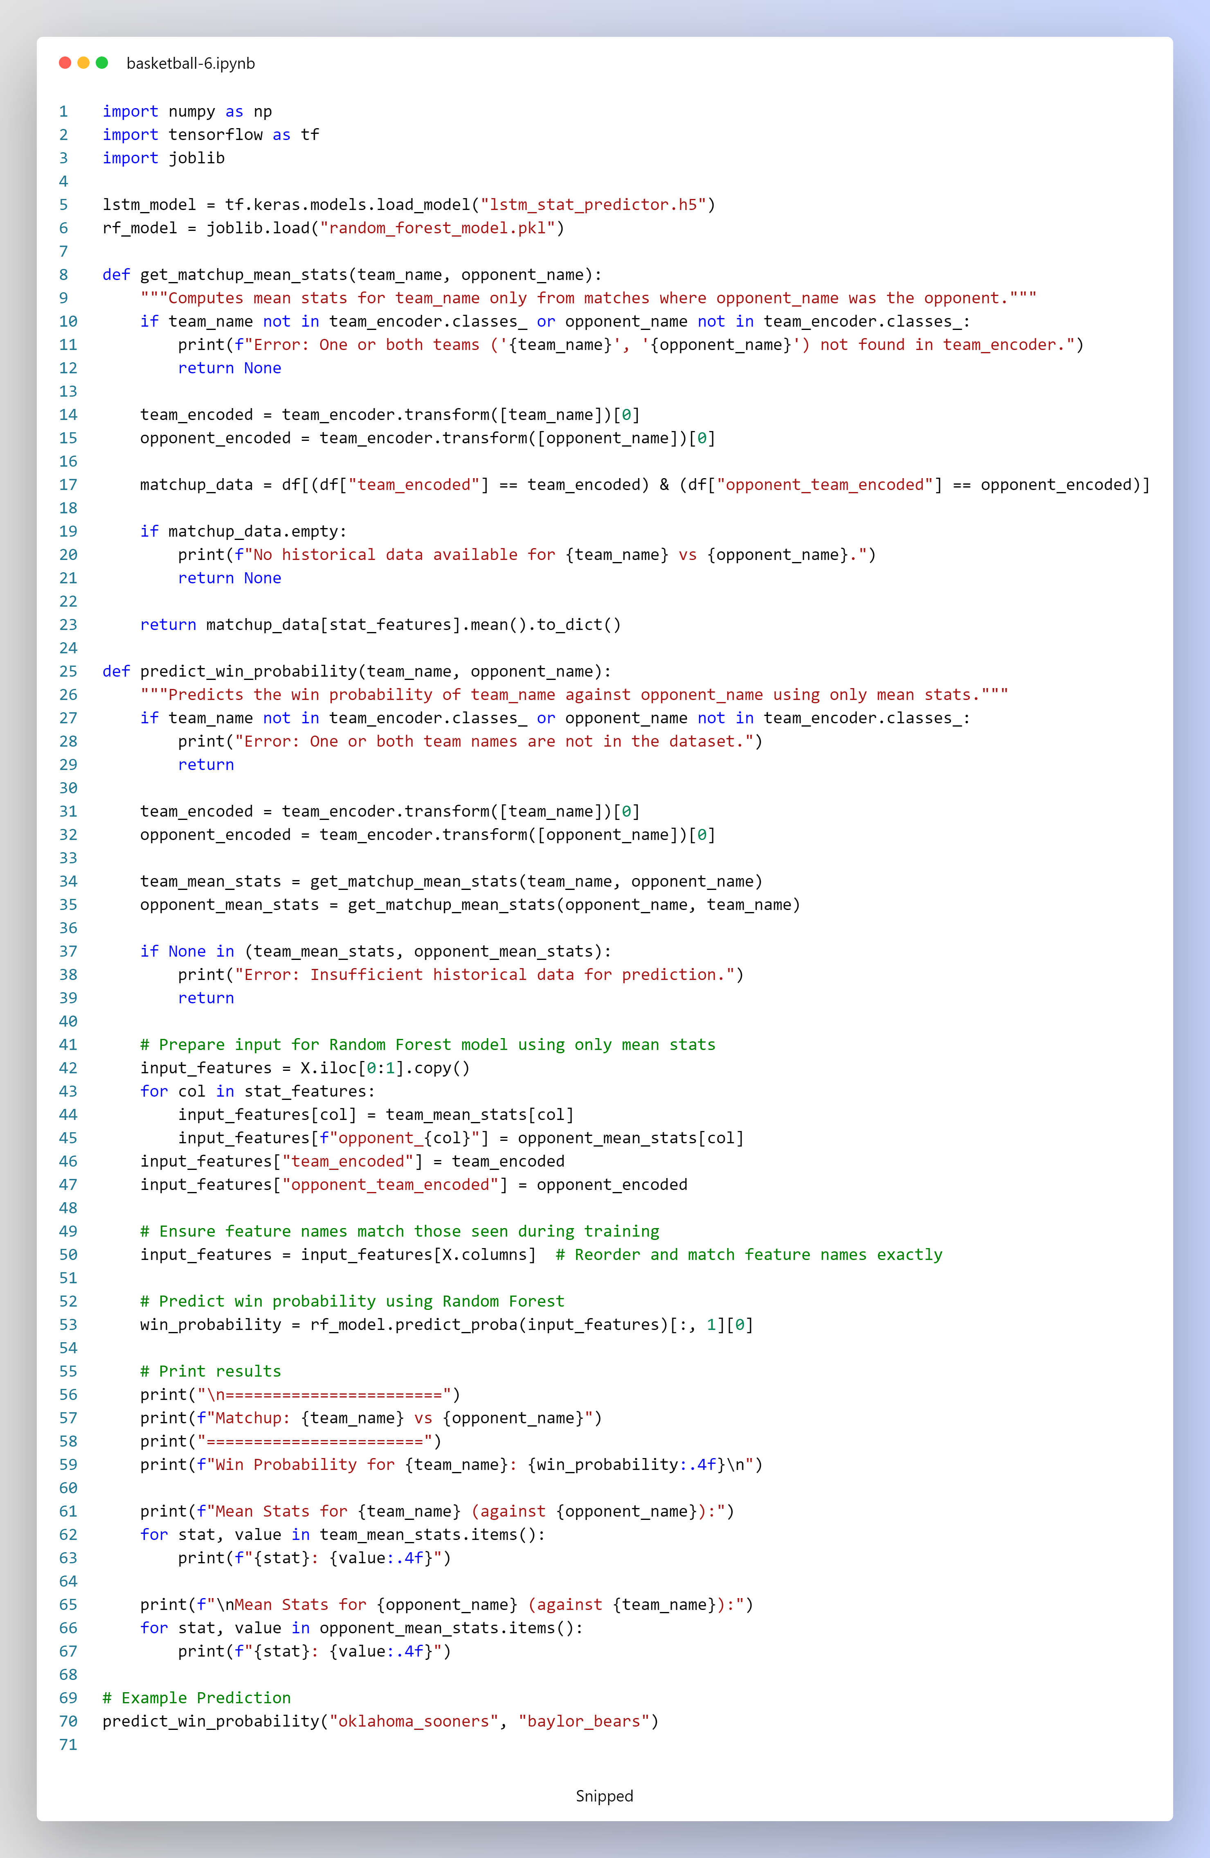

**3. Execution Example**

To run the win probability prediction, the function is called with the names of the two teams. For example:

predict_win_probability("oklahoma_sooners", "baylor_bears")

This call:

* Computes the head-to-head mean statistics for "oklahoma_sooners" when playing against "baylor_bears" (and vice versa).
* Uses these mean stats as the sole input features for the Random Forest model.
* Outputs the win probability for "oklahoma_sooners" and prints the detailed head-to-head mean statistics for both teams.

**4. Summary**

* **Head-to-Head Mean Stats:**  
  The code focuses exclusively on historical matchup data to calculate average performance metrics for both teams.
* **Input Feature Preparation:**  
  The computed mean stats are directly used to form the input for the Random Forest model.
* **Win Probability Prediction:**  
  The Random Forest model predicts the probability that the specified team wins the matchup based solely on these head-to-head mean statistics.
* **Output:**  
  The script prints the matchup details, predicted win probability, and the breakdown of mean stats for both teams.

This explains how this code leverages head-to-head historical mean data to produce a win probability estimate without incorporating any predicted future stats.

**Win Probability Prediction for All Team Permutations**

This script predicts the win probability for every possible matchup (ordered pair) between teams based on both historical head-to-head mean statistics and future predictions obtained from an LSTM model. The final win probability is computed using a Random Forest model that takes as input a weighted combination of these two sources of information.

**1. Overview**

The main steps of the pipeline are:

1. **Loading Models and Data:**
   * The LSTM model (lstm_stat_predictor.h5) is loaded for predicting future statistics.
   * The Random Forest model (random_forest_model.pkl) is loaded to compute win probabilities.
2. **Extracting Unique Teams and Generating Matchups:**
   * The script reads a CSV file to extract the list of unique teams.
   * All possible ordered team matchups are generated using permutations.
3. **Predicting Win Probability for Each Matchup:**
   * For each matchup, the head-to-head historical mean statistics are computed (using a helper function assumed to be defined elsewhere).
   * LSTM-predicted future statistics are also computed for both teams.
   * A weighted combination is calculated (80% mean stats + 20% predicted stats) for both the team and its opponent.
   * These combined features, along with the encoded team identifiers, are fed into the Random Forest model to produce a win probability.
4. **Output:**
   * The predicted win probabilities for all team pairings are saved into a CSV file.

**2. Code Components**

**2.1 Model and Data Loading**

* **LSTM Model:**  
  Loaded with TensorFlow to generate future performance statistics.
* **Random Forest Model:**  
  Loaded with Joblib to calculate the win probability based on input features.

**2.2 Unique Teams and Matchup Generation**

* **get_unique_teams(csv_file):**  
  Reads the CSV file and extracts a list of unique team names.
* **generate_matchups(teams):**  
  Uses itertools.permutations to generate all ordered pairings of teams. (An ordered pairing means that "Team A vs. Team B" is considered distinct from "Team B vs. Team A.")

**2.3 Win Probability Prediction for a Matchup**

* **predict_win_probability(team_name, opponent_name):**
  + Checks that both team names exist in the team encoding.
  + Retrieves the encoded values for each team.
  + Calls helper functions (assumed to be defined elsewhere) to get:
    - Head-to-head mean stats for the matchup.
    - LSTM-predicted future stats for both teams.
  + Computes a weighted combination for each feature:
    - For the team: 0.8 * (head-to-head mean) + 0.2 * (LSTM prediction)
    - Similarly for the opponent (with the feature name prefixed by "opponent_").
  + Prepares an input feature vector that exactly matches the training features for the Random Forest model.
  + Uses the Random Forest model to predict the win probability.
  + Returns the win probability.

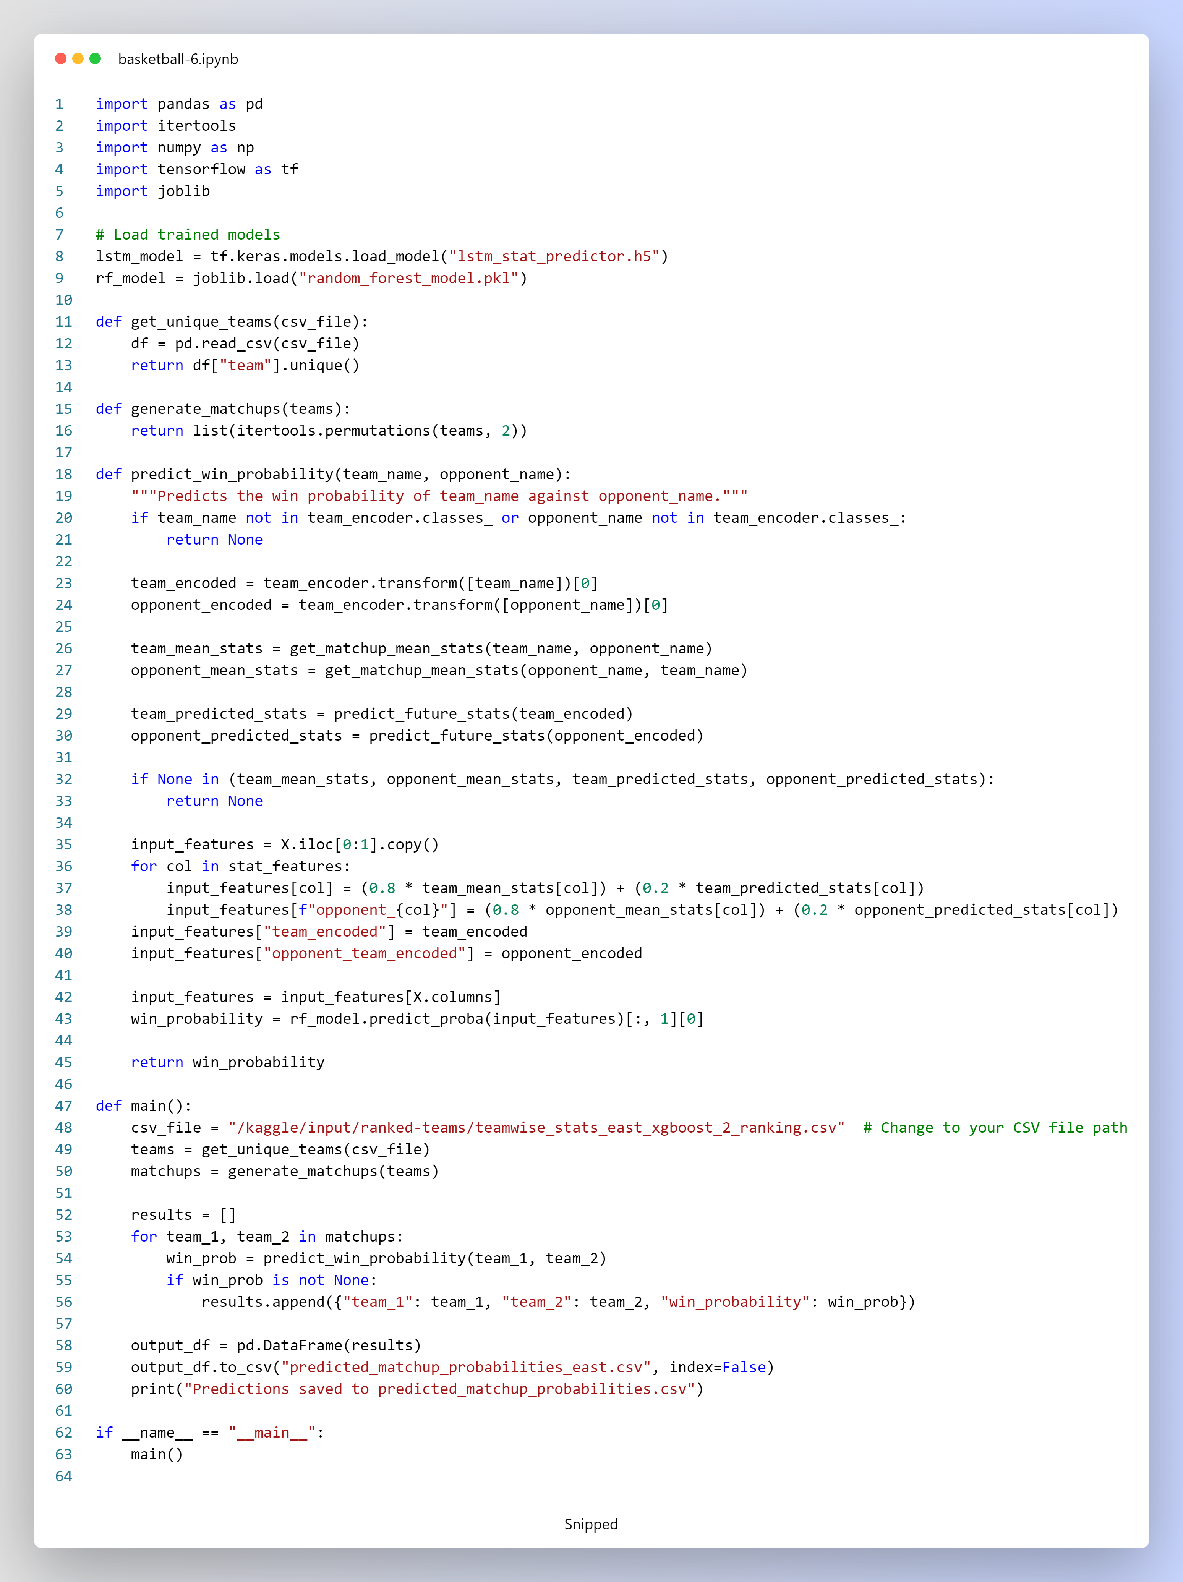

**2.4 Main Execution Function**

* **main():**
  + Specifies the CSV file path containing team statistics.
  + Extracts unique teams and generates all ordered matchups.
  + Iterates over each matchup, predicts the win probability (if data is sufficient), and stores the results.
  + Saves the final predictions to a CSV file (predicted_matchup_probabilities_east.csv).
  + Prints a confirmation message once all predictions are saved.

**3. Summary**

* **Model Loading:**  
  The script loads both the LSTM model (for future predictions) and the Random Forest model (for win probability estimation).
* **Team and Matchup Generation:**  
  Unique teams are extracted from a CSV file, and all possible ordered matchups are generated.
* **Prediction Pipeline:**  
  For each matchup, head-to-head mean stats and LSTM-predicted stats are combined (80% mean, 20% prediction) to form the feature input for the Random Forest model, which then outputs the win probability.
* **Output:**  
  The predictions for all team pairings are saved to a CSV file for further analysis or use.

This code outlines the structure and functionality of your code without altering any lines.